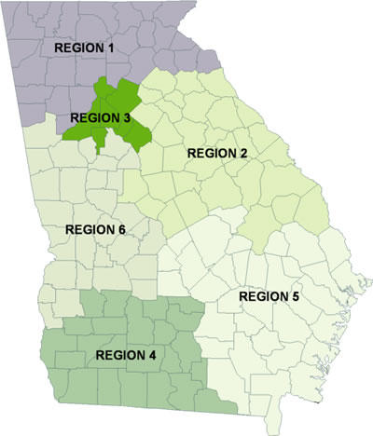
Region 1 Field Office serves the following 31 counties in North Georgia:
Banks, Bartow, Catoosa, Chattooga, Cherokee, Cobb, Dade, Dawson, Douglas, Fanin, Floyd, Forsyth, Franklin, Gilmer, Gordon, Habersham, Hall, Haralson,Hart, Lumpkin, Murray, Paulding, Pickens, Polk, Rabun, Stephens, Towns, Union, Walker, White, and Whitfield.
Region 2 Field Office serves the following 33 counties in East Central Georgia:
Baldwin, Barrow, Bibb, Burke, Clarke, Columbia, Elbert, Emanuel, Glascock, Greene, Hancock, Jackson, Jasper, Jefferson, Jenkins, Jones, Lincoln, Madison, McDuffie, Monroe, Morgan, Oconee, Oglethorpe, Putnam, Richmond, Screven, Taliaferro, Twiggs, Walton, Warren, Washington, Wilkes, and Wilkinson.
Region 3 Field Office serves the following 6 counties surrounding Metro Atlanta:
Clayton, Dekalb, Fulton, Gwinnett, Newton and Rockdale.
Region 4 Field Office serves the following 24 counties in Southwestern Georgia:
Baker, Ben Hill, Berrien, Brooks, Calhoun, Colquitt, Cook, Decatur, Dougherty, Early, Echols, Grady, Irwin, Lanier, Lee, Lowndes, Miller, Mitchell, Seminole, Terrell, Thomas, Tift, Turner, and Worth.
Region 5 Field Office serves the following 34 counties in Southeastern Georgia:
Appling, Atkinson, Bacon, Bleckley, Brantley, Bryan, Bulloch, Camden, Candler, Charlton, Chatham, Clinch, Coffee, Dodge, Effingham, Evans, Glynn, Jeff Davis, Johnson, Laurens, Liberty, Long, McIntosh, Montgomery, Pierce, Pulaski, Tattnall, Telfair, Toombs, Treutlen, Ware, Wayne, Wheeler and Wilcox.
Region 6 Field Office serves the following 31 counties in West Central Georgia:
Butts, Carroll, Chattahoochee, Clay, Coweta, Crawford, Crisp,Dooly, Fayette, Harris, Heard, Henry, Houston, Lamar, Macon, Marion, Meriwether, Muscogee, Peach, Pike, Quitman, Randolph, Schley, Spalding, Stewart, Sumter, Talbot, Taylor, Troup, Upson and Webster.

